Supervision of Children Policy



Approval: | Headteacher:  Lex Beckett | Chair of Governors:  Karen Bye
Last reviewed on: | 8th October 2026
Next review due by: | Sept 27

Contents
Aims 4
Supervisory Responsibilities 4
Before school 6
Supervision Arrangements 6
Break Times 8
Lunchtimes 10
After school 13
Activities Off-site 15
Relationship to other policies (adjust policy names appropriately) 16
Relationship to risk assessments 16
Roles and supervisory responsibilities 16
Arrangements for monitoring and evaluation 17
Appendix A 18
Appendix B 19

Aims
Catsfield CEP is committed to provide, as far as is reasonably practicable, safe playgrounds, outdoor areas and learning environments for the children of our school. This policy seeks to clarify the level of supervision provided before, during and after the school day so that all staff (including contractors, agencies, and third-party organisations) and parents or carers are aware of the standards that are expected.

Supervisory Responsibilities
The headteacher will:
- Ensure that the EYFS ratios, training and supervision levels are always maintained for those in Nursery and Reception.
- Always ensure the maintenance of good order and discipline during the school day when pupils are present on the school premises or on educational visits.
- Ensure adequate staff are available to meet the required supervision requirements for before the start of the school day, during break times and lunch times, and at the end of the school day until all children have left the school grounds or are under parental or carer supervision.
- Organise appropriate training for school personnel.
- Ensure that staff are aware of their supervisory responsibilities.
- Continue to develop a culture of safety and a safe environment for our children.
- Ensure that this policy is communicated to parents or carers.
- Monitor the effectiveness of this policy by speaking with pupils, school personnel, and parents.
- Review and evaluate the supervision procedures as required.

Supervising staff will:
- Support and assist in the implementation of this policy.
- Be aware of the EYFS requirements of supervising those in Nursery and Reception, including the level of training required for staff.
- Reinforce the rules for safe play
- Adhere to and follow the safeguarding and child protection, health and safety, and behaviour policies, and the staff behaviour policy/code of conduct, plus the additional policies listed on page 5.
- Report any concerns to the headteacher or member of the senior leadership team (SLT)/designated safeguarding lead (DSL) as appropriate.
- Understand their prime supervisory responsibility; to be with the class or group all the time. Children should not be put in the position of being left unsupervised. Good preparation and classroom management should ensure that there is no necessity for this to be the case.
- Have a strong awareness of the need for supervision at transition times. This includes supervision of cloakroom/toilet areas, supervision of transition to pick-up time, and supervision of use of toilets at the beginning and end of the school day. Risk assessments must be in place.
- Have an awareness of which pupils have specific health needs/conditions which may warrant an immediate response in an emergency e.g. pupils requiring an inhaler / EpiPen and that emergency medication is available as per an individual plan.

Parents and Carers will:
- Respect the arrangements provided for the supervision of their children and understand the times that supervision will be available.
- Support the supervisory staff by ensuring that their children (including other siblings who may not currently attend the school) adhere to the rules of the school whenever they are on the school site or participating in school events and activities.
- Report any concerns to the headteacher/member of the senior leadership team (SLT)/designated safeguarding lead (DSL) as appropriate.
- Inform the school of any changes to the arrangements for the collection of their child.

Before school
Children, which includes pupils and their siblings, must behave in a way that respects the adults and smaller children on the playground.
- The duty staff go outside at 8.45 to the front gate. Two staff members stands at the gate to ensure no children leave the playground after their arrival.
- From the time that the school takes responsibility for children, all teachers must be ready to receive their class.
- Staff should be available by 8.45am to receive any messages from parents and to bring in children as promptly as possible.
Parent/carers should also note that there will not be staff on duty before 8.45 am and are encouraged to remain with their children until the gates are opened. Should there be any incidents such as bullying or accidents, the school cannot be held responsible and supervisory responsibility will remain with the parent/carer until the time specified above.

The gates will be opened at 8.45am for access to school and will remain open until 9.00am. Any latecomers must report to the main school reception area.

Supervision Arrangements
During the school day all visitors with business in the school will be admitted through the school office where they will sign in and receive a visitor’s lanyard/badge. Certain visitors to the school will be accompanied by a member of staff throughout their visit.
Leaving the school site: Children should not be allowed off-site during school hours unless there is clear evidence of a request (in writing, by email, in person or by telephone) from the parents/carers.
Errands: Children should not be sent off-site on a personal errand on behalf of a member of staff. This includes children collecting items from cars parked in the school car park.
Illness: When children are taken ill during the school day the school will contact the parents/carers, whether at home or at work. Information about contacts is kept in Arbor.
Lesson Time: Children must be supervised always. Children should not be left in classrooms without supervision. Children attending clubs and extra-curricular activities should not be left in school unattended.
The school needs to ensure that arrangements are in place for the safe handover of children attending any clubs or extra-curricular activities.
Visitors: All visitors to the school are expected to sign in and out. Visitors are required to wear a visitor’s lanyard/badge. All staff should check strangers by politely asking why they are on the premises and report to the school office if there is a concern. See visitor lanyard document for colour explanation.
Parents/carers are not allowed to approach children from other families to sort out disputes or arguments; staff or parents/carers should report any concerns about this to the school office.

Break Times
The headteacher or Deputy Headteacher will:
- Review break duty arrangements daily in the event of any staff sickness/absence thereby providing adequate supervision ratios.
- Make the decision about whether it is a wet break time and ensure that there are adequate levels of supervision throughout the premises.
- Provide supervision training for new members of staff to ensure children are safeguarded.
- Whilst EYFS children (Nursery and Reception) are eating there should always be a member of staff in the room with a valid paediatric first aid certificate.
Games/PE
- Children who cannot take part in games activities can join their group as an observer (warm weather only). If this is not appropriate, then children must be designated a class or person and must report to that teacher with some work to do.
Children’s Responsibilities & Duties
- When allocating jobs/tasks to pupils, safety must be a prime consideration. It would not be appropriate for children to be involved with plugging electrical apparatus into the mains unless they were directly supervised, for example. Children doing jobs/tasks must be directly supervised by the teacher.
- Children should not be left in classrooms or communal areas during normal break times without appropriate adult supervision.
- All children have a duty to leave the building promptly during break-time and should be aware that once they have left the building they should not return unless it is to go to the toilet.
- Children who are expected to stay in to finish work are the responsibility of the teacher requesting them to do so and they must be supervised.
Staff will:
- Supervise the children in their care all the time.
- Dismiss their class to the playground and check that supervisory staff are present before leaving the area.
- If it is deemed inadvisable for a child to be on the playground during break times because of their behaviour, the class teacher will make the decision on whether the child should remain inside under the supervision of a member of staff and where they will be supervised.
- Ensure that toilet areas are adequately supervised during break and lunchtimes, ensuring pupils are returning to the playground as soon as possible.
- Once the whistle has blown, children line up in classes on the playground and await their teacher.
Members of Staff on Supervisory Duty: See appendix map/ rota indicating where staff will be located; this identifies any areas where direct supervision should be provided e.g., play equipment
- Must be in the playground from before break time starts and remain there until all the children are sent inside.
- Use high-vis jackets/vests to be easily identifiable and be vigilant always.
- Take a walkie-talkie outside to communicate with the office
- Not indulge in protracted conversation with other members of staff.
- Deal with any incidents of behaviour and report them to the relevant member of staff.
- Report any safeguarding incidents/concerns to the DSL/Deputy DSLs immediately via the school system.
- Must be clear about the procedures in relation to the administration of emergency medication during lunch and playtimes. The box of medication must be taken outside at break and lunch.
- First Aid will be administered by trained adults. A form must be completed and the grren sheet given to the child to take home and the duplicate to remain in the file in the office. Head bumps must be looked at by office staff and parents informed via PING.

Lunchtimes
The headteacher will make the decision about whether it is a wet lunchtime and review arrangements daily in the event of any staff sickness/absence to ensure there are satisfactory levels of supervision throughout the lunch break. It is considered that these adults have a very important role within the school and the contribution they make to the management of the school, and the care and welfare of the children, is valued very highly. The Headteacher is responsible for the management, training, and welfare of the supervisors in school. The playground will be supervised at lunchtime by staff wearing high vis jackets in designated areas-see appendix map /rota/schedule of where staff should be located and identify any areas where direct supervision should be provided if appropriate e.g., play equipment and other areas that out of bounds. Communication between the supervising members of staff and the school office is undertaken in person or by walkie-talkie. In the event of an incident or unexpected occurrence, the headteacher will ensure additional support will be provided to assist in the situation. The headteacher can be communicated by walkie-talkie.

The Role of the Staff on Duty at Lunchtime
Staff on duty at lunchtime are responsible for:
- Supervising children on the school site as required by the headteacher.
- Ensuring EYFS children (Reception) always being within sight and hearing whilst eating. Where possible, staff should sit facing children whilst they eat so they can make sure children are eating in a way to prevent choking and so they can prevent food sharing and be aware of any unexpected allergic reactions.
- Whilst EYFS children (Reception) are eating there should always be a member of staff in the room with a valid paediatric first aid certificate.
- Dealing with minor incidents and accidents following the health and safety policy.
- Being clear about the procedures in relation to the administration of emergency medication during lunch and playtimes e.g., inhalers and EpiPens themselves or which staff member has delegated responsibility to manage this.
- Organising activities for the children during wet lunch breaks-see wet break rotas; staff must not leave their designated areas.
- Over-seeing children’s care and welfare during the lunch break, especially in the playground.
- Undertaking training as required.
- Reporting any safeguarding incidents/concerns to the DSL/DDSL as soon as possible via the agreed systems.
General organisation
Each member of staff on duty at lunchtime has a specific role to play within the general organisation and is given a specific schedule to follow. The tasks are timetabled; staff must keep to the schedule.
General duties
Members of staff on duty at lunchtime are responsible for:
- Supervising children eating their lunch.
- Managing the children’s behaviour, including orderly queuing.
- Monitoring the playground, cloakrooms, and classrooms to make sure children are safe.
- Making sure all children observe the behaviour policy.
- Ensuring the dining hall is cleared up after use.
- Assisting children with their meals as necessary.
- First Aid will be administered by office staff. Emergency medication will be kept in the office and the Allergy Action Plan followed.
Guidelines
- Do not stay in one place for any length of time (within your designated area).
- Make sure you supervise the areas of the school building for which you are responsible.
- Inform the Headteacher /DSL if you become aware of an area which you believe requires additional vigilance or falls outside of sightlines in terms of supervision.
- Do not stand talking to other staff or spend a long time with one group of children.
- Follow the school’s behaviour policy.
- Aggressive play, bullying or concerns should be reported to the class teacher and/or SLT.
- Record all accidents in the minor injuries record and seek help if the accident is a cause for concern.
- Read the health and safety policy for advice.
- Watch the games the children are playing, but do not get too absorbed, as it might distract you from what is going on elsewhere-be vigilant.
- Avoid playing games with the children after you have initiated them; encourage play between them to facilitate a high level of supervision.
- Pass all lunchtime issues to appropriate staff e.g., class teacher/DSL.
- Treat the children fairly, equally and with respect.
- Be vigilant of groups of mixed-age children; pay attention, particularly, to EYFS/KS1 pupils.
- Be vigilant of pupils with complex special educational needs and disabilities/behavioural needs. This may include having an awareness of what measures should be implemented in response to specific behavioural incidents to ensure the safety of others and appropriate support for the individual pupil.

After school
The doors for all classes will open at 3.20. The class teachers will escort the children to the doors and ensure that they are met and collected by an appropriate person unless they have permission to walk home (Years 5 and 6 only). The class teacher should use the home time collection list provided by the office. Where a child has said they have permission to walk home but this has not been confirmed, advice needs to be sought before the pupil is allowed to leave the school site.
Staff MUST NOT release children to persons that are not known to them, and parents/carers must communicate any alternative arrangements to the school if they wish their children to be collected by another named person.
Children should never wait outside for lifts or taxis. They should be collected from the reception area.
For pupils who qualify for travel assistance and are transported to and from school via a taxi and/or other school transport, staff should ensure that unfamiliar/new transport personnel are confirmed as the appropriately assigned persons to transport that pupil. They will check and seek reassurances before releasing the pupil.

The vehicle gates will remain closed between 9.00am and 3.20 pm at the end of the school day.

Children, which includes pupils and their siblings, must behave in a way that respects the adults and smaller children on the playground at the end of the school day.

Safeguarding – After School Provision
- The school and club leaders will ensure that a clear procedure is in place for the transition of children from school to after school provision and that this is known and understood by all.
- It is the school’s responsibility to ensure third party providers are prepared to adopt the school’s policies.
- All providers will be informed of the systems, procedures, and expectations for safeguarding.
- It is the responsibility of the provider to contact SPOA / the Headteacher/ Designated Safeguarding Lead (DSL) in the event of a safeguarding incident / concern e.g., child disclosure.
- All club leaders will have a current DBS certificate. The school will make clear to third party providers what is expected of them in terms of a safe working practice with children and young people and record that they have done this. All club leaders are given a copy of the document ‘Keeping Children Safe in Education’ (DfE – 2026).
- Insurance: All third-party providers offering activities provide a copy of their public liability insurance and their employer liability insurance as appropriate.
- It is important that the school ensures that they have written confirmation from third party providers that their staff have been safely recruited.
Club Expectations
All club leaders ensure that every term there is a reminder about the procedures in case of a fire, rules for moving around the school building, arrangements for going to the toilet, expectations of behaviour, and changing arrangements. Registers of attendance must be taken at the start of each session.
Special Arrangements
Upon the completion of after school clubs, sporting occasions or off-site activities that have been planned to finish after the end of the school day, parents/carers are asked to collect their children from the main entrance. Staff will ensure that children are only released to a known person unless prior permission has been given to either walk home alone (Years 5 and 6 only) or be collected by another named person.
Pupils who qualify for travel assistance after school staff will ensure that they do not release pupils unless they are aware that said arrangements have been put in place.
This whole section may need revising depending on each school’s arrangements and phase.

Activities Off-site
During all class trips/ activities off-site staff have a heightened responsibility for supervision and must always follow procedures and risk assessments.
All Other Times
Parents/carers must be aware that the school will not provide supervision for children in the playground outside these times, including open days, parents’ evenings, and parent events. The children will be the supervisory responsibility of the parents/carer at all other times other than those stated in this policy.

Relationship to other policies
- Early Year Foundation Stage Framework
- Behaviour Policy
- Anti-bullying Policy
- Safeguarding and Child Protection Policy
- Health and Safety Policy
- ESCC First Aid Policy and Guidance
- ESCC Model Supporting Children with Medical Conditions Policy
- ESCC Model Health and Safety Policy
- ESCC Incident Reporting Policy and Guidance
- ESCC Policy on Outdoor Play Equipment
- Educational Visits Policy
- Crisis Management Plan

Relationship to risk assessments
- EYFS
- First aid
- Security
- Movement around school
- Playground activities
- Play equipment
- Slips, trips, and falls
- Access and egress
- Individual pupil risk assessments

Roles and supervisory responsibilities
This policy applies to:
- All staff and contractors, agency, and other third-party organisations
- Children
- Parents/carers (at dropping off and picking up times).

Arrangements for monitoring and evaluation
The designated safeguarding lead will monitor the minor injuries recording forms/ behaviour logs, individual pupil risk assessments where appropriate and bullying incidents to ascertain whether there are recurring trends and how they could be resolved.

Appendix A

A map of the school showing any areas which are out of bounds to children, the position of staff when on duty outside plus other relevant information for each school.

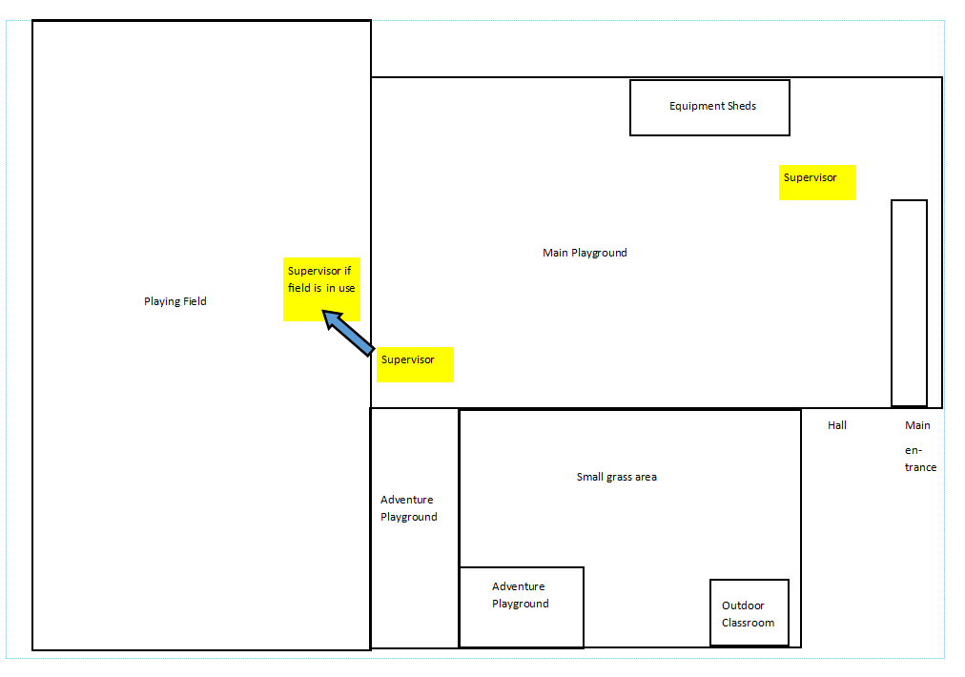

Appendix B - A letter which is used to gather the collection arrangements for the children.

Dear parents/carers,

At Catsfield CEP we regard the security and the safety of children and adults as a priority. Children will only be allowed to leave the school with a parent/carer or someone authorised by their parents/carers, unless they are in years 5 and 6 when they can walk home provided you give permission. It is vital that collection details are clarified, and emergency contacts are correct, as we may need to contact you urgently. Please could you complete the attached form and return it to school as soon as possible.

We realise that there will always be days when your normal arrangements are not possible – we just ask that you ring into reception as early as possible to inform us, so that we can let your class teacher know.

Please collect your child promptly. If you, or the person collecting your child, are going to be late please telephone to inform us. If you are late your child will be waiting in the main entrance in the school, this ensures that they are with an adult.

You may also note if there is anyone who you DO NOT want your child collected by. If you would like to discuss a difficult situation, please either speak to your child’s class teacher or call the school to arrange an appointment with the headteacher.

Thank you for your support and we appreciate your patience in this.

Yours sincerely,

Designated safeguarding lead
………………………………………………………………………………………………………………………………
Child’s name: Class:__________
The person who will normally pick up my child is:
Name relationship
Tel: home mobile

If each day is different please state or if they are attending an after-school club, please give details below:
Monday:
Name relationship
Tel: home mobile

Tuesday:
Name relationship
Tel: home mobile

Wednesday:
Name relationship
Tel: home mobile
Thursday:
Name relationship
Tel: home mobile

Friday:
Name relationship
Tel: home mobile

I give permission for my child to walk on their own: ___________

Other arrangements (e.g. a person who you DO NOT wish to collect your child – please provide further information/documentation)

Print name (parent/carer)
Signed Date

