Catsfield Church of England Primary School
Nurture the Spirit – Grow the Mind – Love your Neighbour
2 Timothy 1:6: Stir up the gifts that are within you!


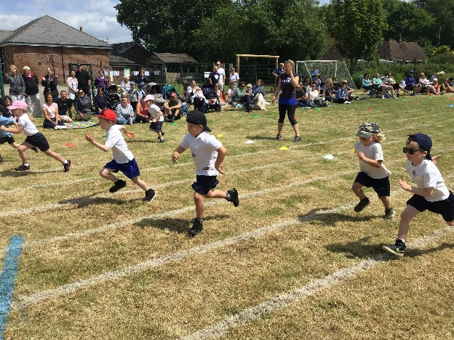

Evidencing the Impact of Primary PE and Sport Premium
2025-26

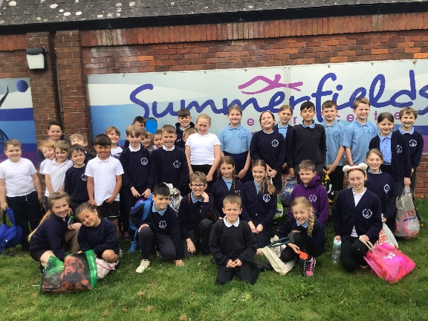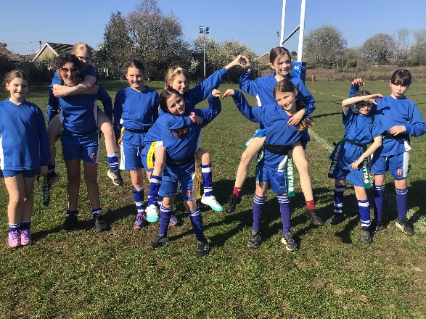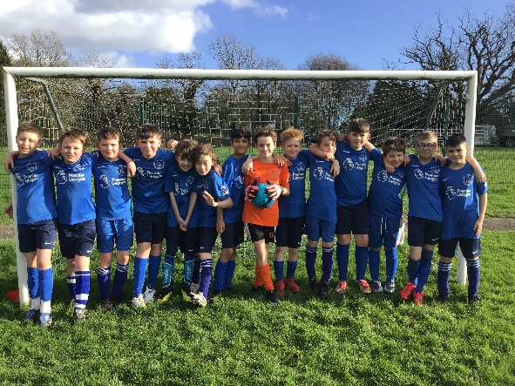

Key achievements to date: | Areas for further improvement (academic year 2026-27):
Academic year 2025-26:  - Gold School Games mark achieved  - Participation in 13 inter-school events  - Success at ‘Time 2 Dance’ festival  - Swimming unit successfully completed with a broader offer to now include Y3,4 and 5 and with lessons lasting 60 min rather than 30.  - Work with an external provider for CPD and working alongside children  - Successful Forest School | - Time2Dance: Increase boys participation  - Maintain Gold School Games mark  - To continue to increase, inspire and sustain the number of children participating in at least 30 minutes of physical activity a day in school  - Further develop positive attitudes towards physical literacy (relationship with movement and physical activity throughout life)

Meeting national curriculum requirements for swimming and water safety
What percentage of your current Year 6 cohort swim competently, confidently and proficiently over a distance of at least 25 metres?  N.B. Even though your pupils may swim in another year, please report on their attainment on leaving primary school at the end of the summer term 2025. | 87.5%
What percentage of your current Year 6 cohort use a range of strokes effectively [for example, front crawl, backstroke and breaststroke]? | 87.5%
What percentage of your current Year 6 cohort perform safe self-rescue in different water-based situations? | 87.5%
Schools can choose to use the Primary PE and Sport Premium to provide additional provision for swimming but this must be for activity over and above the national curriculum requirements. Have you used it in this way? | Yes  Y3 – above and beyond  Y4 – statutory national curriculum requirements  Y5 – above and beyond

Academic Year: 2025/26
Total fund allocated:
Date Updated: July 2026
Key indicator 1: The engagement of all pupils in regular physical activity – Chief Medical Officer guidelines recommend that primary school pupils undertake at least 30 minutes of physical activity a day in school |  |  | Percentage of total allocation: 59.6%
Intent | Implementation | Impact
Your school focus should be clear what you want the pupils to know and be able to do and about what they need to learn and to consolidate through practice: | Make sure your actions to achieve are linked to your intentions: | Evidence of impact: | Sustainability and suggested next steps:
PE curriculum time protected – 2 x 1 hr lessons per week. Clear progression of skills through the year.  To ensure ‘Sports Crew’, MDSAs (including play leader) receive sufficient and regular training and meetings.  Every child participates in daily mile  PE lead to ensure ‘Sports Crew’ have termly meetings.  Tigers to use bikes 1 x per week following Bikeability in September | Clear timetable of PE provision and bike use in Tigers  Set personal challenges and celebrate success (Star Assembly and display board)  Teacher to lead and demonstrate exercises safely for pupils to follow along.  Develop pupil leadership skills by training up more children to join our ‘Sports Crew’ – create rota for lunchtimes (support MDSA play leader). | Purpose-built track has ensured that every class (children and adults) complete ‘The Daily Mile’ every day – resources are being used effectively.  Successful use of play leader has led to more activities and games provided at lunchtimes to support active play.  Training has been provided for the ‘Sports Crew’ to help and develop the leadership skills. Class teacher supporting when needed across the year.  Trim trail: children have a rota to use it once a week and enjoyed by all. | - Improved teacher knowledge and understanding ensures impact of PPSP will continue beyond its lifespan  Next Steps:

Key indicator 2: The profile of PESSPA being raised across the school as a tool for whole school improvement |  |  | Percentage of total allocation:
 |  |  | 68.1%
Intent | Implementation | Impact | Sustainability and suggested next steps

LS Coaching to create portfolio and promote to pupils at every opportunity – update throughout the year.  Children to understand application of schools values to PE based scenarios  Children take part in values based sports events such as Sports Day and Football Tournament. | Year 6 children to complete ‘Bikeability’ – road safety.  Staff (and children) know what the School Values are and promote these, linked to athletes when the opportunity arises.  PE lead/ Sports coaches to create portfolio and promote to pupils at every opportunity – update throughout the year.  Ensure release time is booked in and taken.  Swimming unit to be organised for Y3/4/5 and offered above and beyond to required year groups.  Mrs Skevington to lead assembly on water safety.  RNLI to lead session on water safety with KS2. A;; pupils to take part in pre, during and post suveys.  Further intra-school competition linked to values and vision | School sport and PE is a key aspect of school life and whole school development – increased awareness of achievements in and out of school.  Year 6 children also completed ‘Bikeability’ to ensure they know how to remain safe when travelling to and from school.  PE updates and achievements sent home in newsletters.  2x Display board in hall to share successes – 1 for school events, 1 for achievements outside of school.  Year 3/4/5 completed swimming block in Term 4/5.  Accurate Year 6 swimming data provided.  Children are aware of Mrs Skevington's DDSL role in raising awareness of keeping safe. | - School Values are an integral part of the school life, ensuring impact of PPSP will continue beyond its lifespan  Next Steps:

Key indicator 3: Increased confidence, knowledge and skills of all staff in teaching PE and sport |  |  | Percentage of total allocation:
 |  |  | 42.2%
Intent | Implementation | Impact | Sustainability and next steps
Improve staff confidence and quality of teaching and learning in PE across the school – ensure children have a positive experience of being active.  To employ LS Coaching to improve staff confidence and quality of PE teaching.  To understand the quality and impact of PE provision across the school with both internal staff and external coaches.  To use Funk Fusion to deliver dance curriculum. | PE co-ordinator to attend HRSGP (Hastings and Rother School Games Partnership) training events across the year when possible – ensure all staff are up to date with current guidelines.  LS Coaching coaches to be observed – ESCC guidance used to support and guide conversations.  Re-introduce a monitoring process of the subject leader observing lessons across school when PE is focus subject on 2-year rolling programme. | Staff developing awareness and understanding of how to better deliver a school sport curriculum.  Staff skill base improved with access to external providers. | - Improving teacher knowledge ensures the impact of PPSP will continue beyond lifespan.  Next steps:

Key indicator 4: Broader experience of a range of sports and activities offered to all pupils |  |  | Percentage of total allocation:
 |  |  | 51.2%
Intent | Implementation | Impact | Sustainability and suggested
To employ LS Coaching to improve staff confidence and quality of PE teaching alongside curriculum delivery to all classes.  To strengthen links with local community clubs: Funk Fusion, Sussex Cricket  Children develop an awareness and understanding of diversity and representation in PE.  Inter-school events against Crowhurst School – football and rounders. | External sports coaches to run before school clubs: 1x weekly (Funk Fusion), after school clubs 5x weekly (LS Coaching) and lunchtime clubs 1x weekly (LS Coaching).  School to take part in Time2Dance Festival.  Continue with a learning ladder reward day with a PE link once a year. | Children are actively taking up clubs to be active at lunchtimes. Parental and pupil feedback was hugely positive from those attending.  School successfully took part in Time 2 Dance with 15 pupils taking part.  Linking healthy living/ lifestyle to whole school learning. Choices given aim to broaden the experiences of all pupils.  Gold School Games Mark achieved this year | - Through the positive relationships we have made, clubs/coaches are already providing their services free of charge/at a reduced rate in order to recruit pupils towards their clubs and sports.  Next Steps:

Key indicator 5: Increased participation in competitive sport |  |  | Percentage of total allocation:
 |  |  | 23.3%
Intent | Implementation | Impact | Sustainability and suggested
HRSGP membership will allow pupils to experience a range of different inter-school competitions and festivals.  Children to take part in events hosted by Battle Abbey  Children show a positive attitude towards trying new sports and competitive activities.  Children apply learned skills effectively during competitive games and activities.  Children demonstrate understanding of rules and tactics in a range of competitive sports.  Children work cooperatively with teammates and show respect for opponents and officials.  Children take on leadership roles such as team captain or helping to organise teams.  Children set personal goals related to competitive sport participation and works towards achieving them. | Join HRSGP for the academic year and attend competitions and festivals when possible.  Introduce opportunities for intra-school competition (encourage use of the House system).  Date set for annual Sports Day – mixture of team/individual competition.  Continue to track data for clubs and competitions within school.  Provide opportunities for every child to compete as part of a team through intra-school competition.  Apply for School Games Mark Term 6 2026 – recognising sporting opportunities we offer children and maintain Gold School Games Mark.  Introduce system for children to set personal goals related to competitive sport participation and works towards achieving them | School achieved Gold School Games mark.  The school took part in 11 inter-school events with a large number including top 3 finishes with children using and applying skills learnt in school.  The Claverham PE lead completed an indoor athletics session with every year group in the school.  Sports day redesigned to increase competitive element – parent feedback was incredibly positive.  Children take on role of ‘Captain’ in tournaments and encourage good sportsmanship in teams. | - The HRSGP membership enables the PE lead and other school staff to form relationships with schools in the local area making the organisation of future competitions more sustainable year on year  Next Steps:

Signed off by
Acting HeadTeacher: | Lex Beckett
Chair of Governors | C. Buckland
Date: | July 2026
Subject Leader: | Lex Beckett

Online Reporting of PE and sport premium grant expenditure

